**SNACKS CENTRE ONLINE DELIVERY SYSTEM**

**LOW LEVEL DESIGN**

Process Overview:

* The purpose of this project is to implement a snacks center delivery system. Allows users to view the snacks center login page by entering the details user can be able to see the menu list of the admin panel. And admin want to do any changes in the admin panel the admin want to enter the user name and password and then the admin will procced to changes.
* Then prepares the customers order and delivers the order to customer if the items and distance should be beyond the limit.

**Procedure flow:**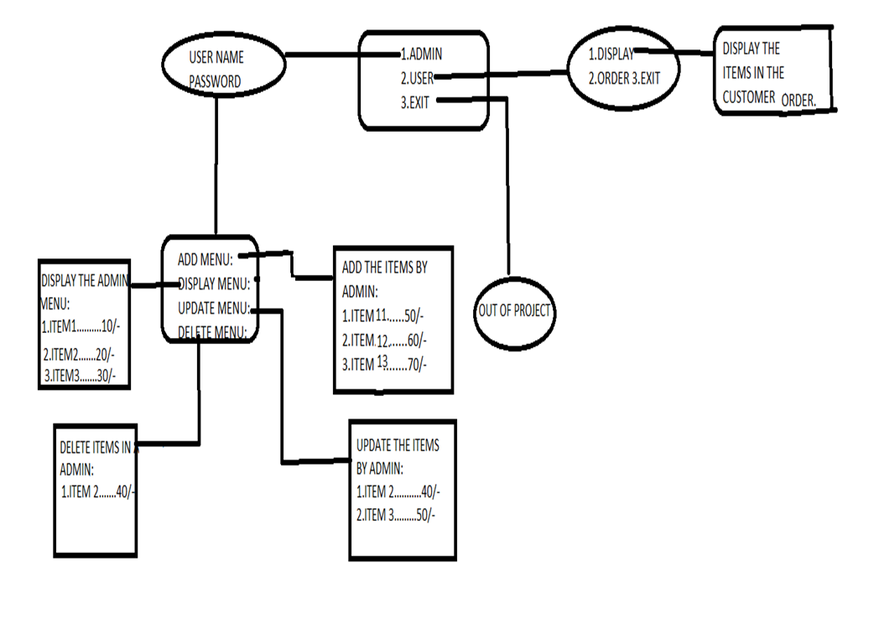

**For User Login**

The user must login by giving details like user name and the mobile number. After login successfully into the snacks centre page it displays the details related to menu list like number of items price.

**Failure Login**

If the user is missed to give the details like name and mobile number then the process will stops up-to there. We can not able to move further process.

**Admin Validation For User**

The user want to give the name and the password based up-on the login details the admin can validates the account of the user and procced to place the order. And the order ID will be also consider.

**Communication Exchange**

The owner can see the order details and then the owner can accept the order and if the customers order up-to 3 items and below the 10 kms then the owner confirms the customers order.

MENU INFORMATION

1.For the new customer the snacks center page displays

the1.ADMIN 2.USER 3.EXIT.

2.When we chooses the 1.Admin asks the details like user name and password.

**ADD MENU:-**

The admin can be able to add the items into the menu that added items will be updated to the customers in the menu list.

**DISPLAY MENU:-**

In the display menu we are able to see the items present in the menu page. By that display menu we can order the items that the user want.

**UPDATE MENU:-**

The update information is done by the admin to change the items and update the price of item or add or delete the menu.

**DELETE MENU:-**

We can delete items in the menu list if the don’t want the item. The deletion of items can be done bythe admin.

Logout:

The logout depends upon the successful credentials and billing.

When the customer may order more than 3 items or distance is above than 10 kms then it leads to direct exit/logout from the project.

**ENTIRE WORKING OF THE PROJECT**:-

* The Entire project will be based upon the admin and user.
* The admin and the user will be based upon the admin panel.
* The admin is able to login into the admin panel by giving the name and the password.
* The admin is able to do the changes in the menu, That to add the items, delete items, update items.
* The user want to login in to the admin panel by giving the user name and the mobile number.
* The admin panel asks the user the distance from the snacks center to the location of the user,
* If the distance is more than the 10kms and the item limit is up-to 3.
* If the customer is beyond the conditions of the admin the order will be placed successfully.
* Or the distance is more than 10kms and the items is more than 3 items then the order will not be placed.
* If the distance and items count will be accepted then the user is able to display the menu list.
* And he will be able to place the order successfully.
* And the total billing would be done for all items.
* Next, the order will be delivered successfully.